**Cars**

**Electric**

**Coupe (Pending)**

**Sedan**

**SUVs**

**Compact (Pending)**

**Sports**

**Super (Pending)**

**Electric cars**

**Name:** Tesla model X

**Mileage:**

**Transmission:** Automatic

**Seats:** 7 seats

**Luggage:** 6 bags

**Fuel:** Electric

**Description:** With the most power and quickest acceleration of any SUV, Model X Plaid is the highest performing SUV ever built. All Model X powertrains, with updated battery architecture, can deliver instant torque at any speed.

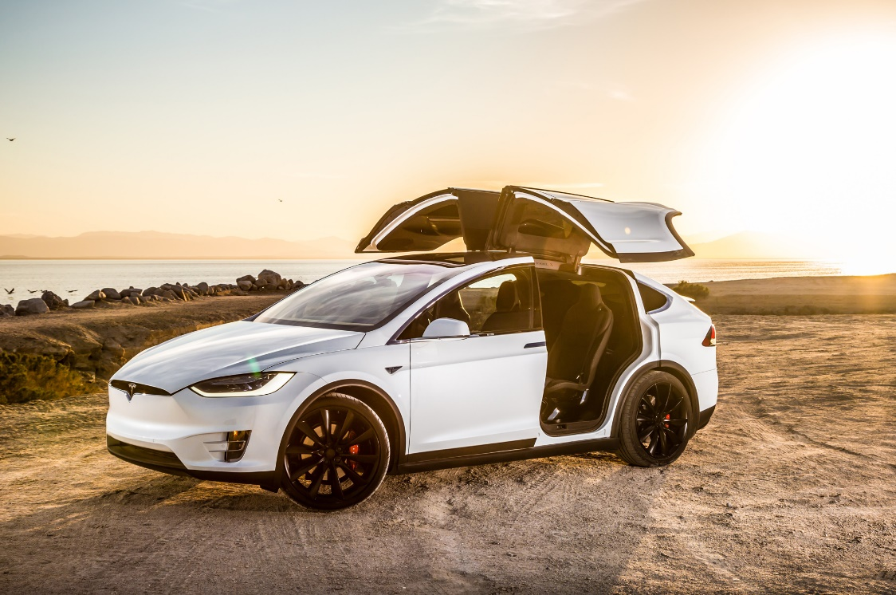

**Features**

|  |  |  |  |  |  |  |  |  |  |
| --- | --- | --- | --- | --- | --- | --- | --- | --- | --- |
| \\ | AC | Child Seat | GPS | Bluetooth | Screen | Parking Sensor | Cup holders | Phone charging | Cruise Control |
| Y/N | **Y** | **Y** | **Y** | **Y** | **Y** | **Y** | **Y** | **Y** | **Y** |

__________________________________________________________________

**Sedan cars**

**Name: Toyota corolla 2020**

**Mileage:**

**Transmission:** automatic

**Seats:** 5

**Luggage:** 4 bags

**Fuel:** Petrol

**Description:** With an excellent fuel economy, boasting an EPA-estimated 31 cities and 40 highway mpg rating, the standard Toyota Safety Sense™ 2.0 package and much more, the 2020 Toyota Corolla is prepared to give every driver a smooth, modern and exciting experience.

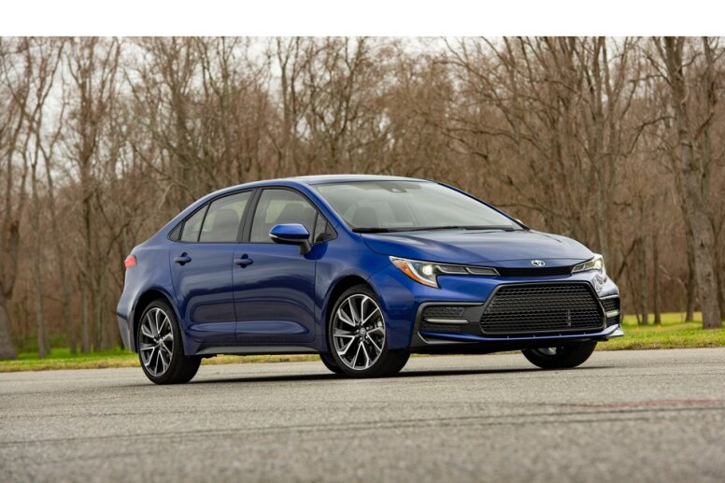

**Features**

|  |  |  |  |  |  |  |  |  |  |
| --- | --- | --- | --- | --- | --- | --- | --- | --- | --- |
| \\ | AC | Child Seat | GPS | Bluetooth | Screen | Parking Sensor | Cup holders | Phone charging | Cruise Control |
| Y/N | **Y** | **Y** | **N** | **Y** | **N** | **Y** | **Y** | **N** | **N** |

__________________________________________________________________

**Name:** Hyundai

**Mileage:**

**Transmission:** Automatic

**Seats:** 5 seats

**Luggage:** 3 bags

**Fuel:** Petrol

**Description:** The Hyundai Elantra is a four-door sedan with five seats. The front seats are supportive and decently cushioned, and there's sufficient headroom and legroom for taller occupants. It's easy to find a comfy driving position, thanks to the range of seat and steering wheel adjustments.

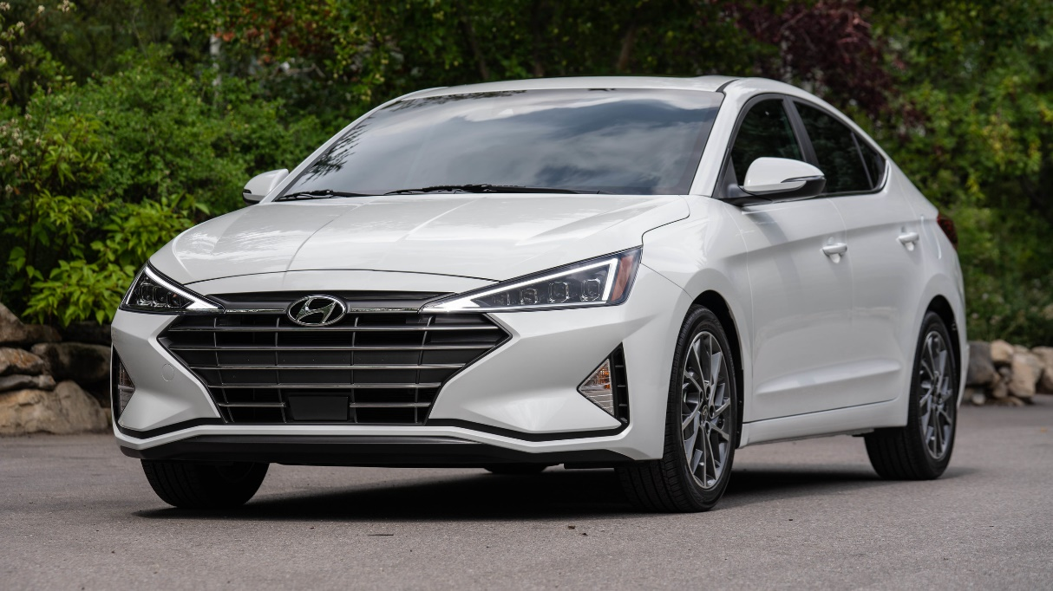

**Features**

|  |  |  |  |  |  |  |  |  |  |
| --- | --- | --- | --- | --- | --- | --- | --- | --- | --- |
| \\ | AC | Child Seat | GPS | Bluetooth | Screen | Parking Sensor | Cup holders | Phone charging | Cruise Control |
| Y/N | **Y** | **N** | **N** | **Y** | **Y** | **Y** | **Y** | **N** | **N** |

__________________________________________________________________

**SUV cars**

**Name:** Jeep wrangler

**Mileage:**

**Transmission:** Automatic

**Seats:** 5 Seats

**Luggage:** 4 Bags

**Fuel:** Petrol

**Description:** It's not the most spacious or accommodating SUV available, but the Wrangler provides a seamless blend of vintage and modern Jeep character. A commanding view of the road or trail makes for easy maneuverability, but the view rearward is obscured by thick roof pillars, roll bars, and various grab handles. Need a better view? Just pop the top and remove the doors.

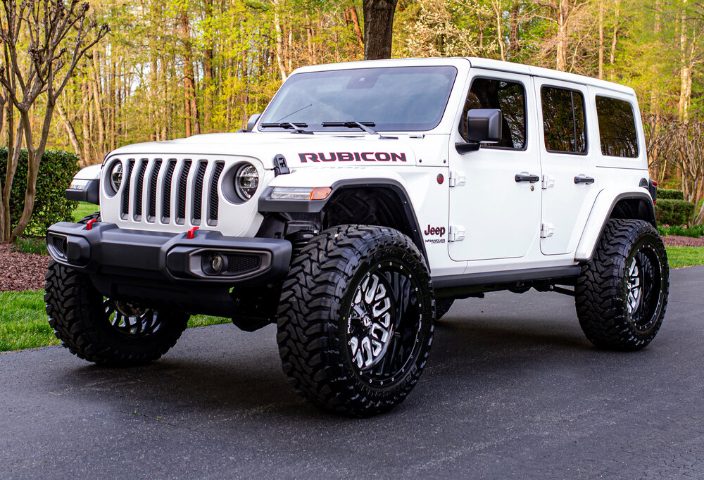

**Features**

|  |  |  |  |  |  |  |  |  |  |
| --- | --- | --- | --- | --- | --- | --- | --- | --- | --- |
| \\ | AC | Child Seat | GPS | Bluetooth | Screen | Parking Sensor | Cup holders | Phone charging | Cruise Control |
| Y/N | **Y** | **Y** | **Y** | **Y** | **Y** | **Y** | **Y** | **N** | **N** |

__________________________________________________________________

**Name:** Honda C-RV

**Mileage:**

**Transmission:** Automatic

**Seats:** 7 seats

**Luggage:** 5 bags

**Fuel:** Petrol

**Description:** The Honda CR-V is a brilliant small SUV due to its high competency across the board. It has exceptional storage space and functionality, plenty of features, a comfortable ride and enjoyable performance. And all of that comes at a competitive price for the class.

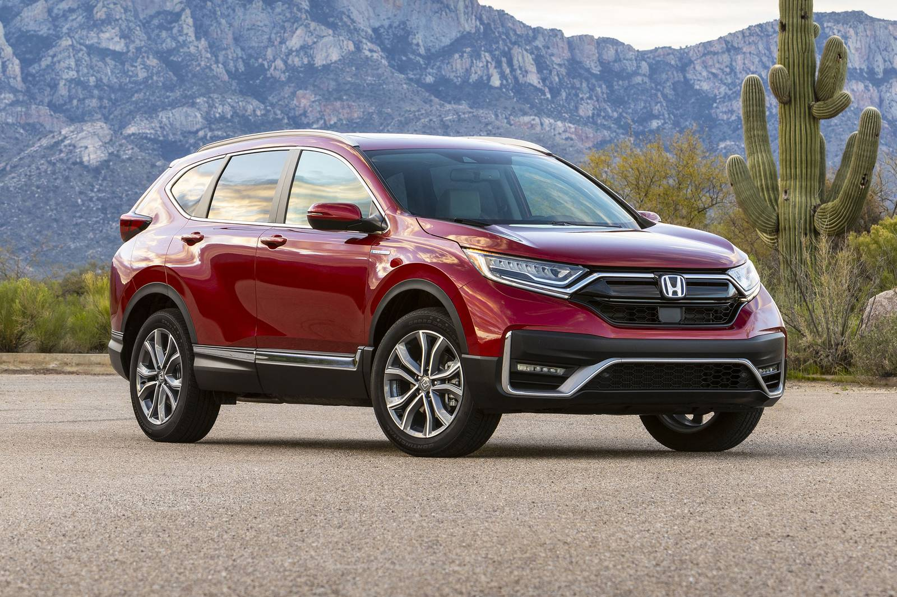

**Features**

|  |  |  |  |  |  |  |  |  |  |
| --- | --- | --- | --- | --- | --- | --- | --- | --- | --- |
| \\ | AC | Child Seat | GPS | Bluetooth | Screen | Parking Sensor | Cup holders | Phone charging | Cruise Control |
| Y/N | **Y** | **Y** | **N** | **Y** | **Y** | **Y** | **Y** | **N** | **Y** |

__________________________________________________________________

**Sports cars**

**Name:** Ford GT 500

**Mileage:**

**Transmission:** Manual

**Seats:** 4 seats

**Luggage:** 4 bags

**Fuel:** Petrol

**Description:** The 2021 Ford Shelby GT500 is an ultra-high-performance variant of the standard Ford Mustang. Under the hood is a 5.2-liter supercharged V8 (760 horsepower, 625 lb-ft) that is connected to a seven-speed dual-clutch automatic transmission driving the rear wheels.

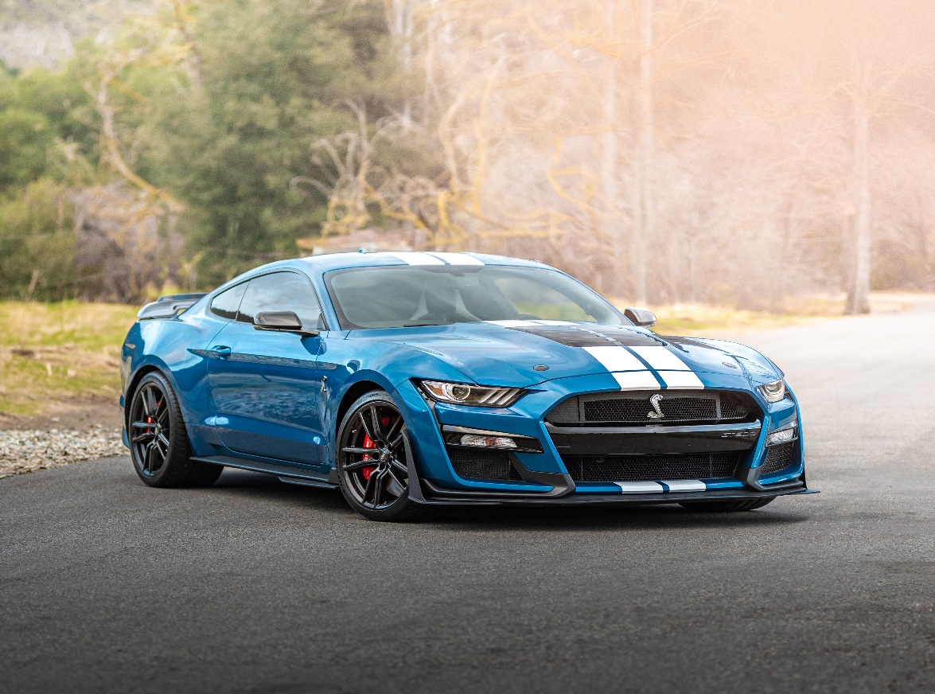

**Features**

|  |  |  |  |  |  |  |  |  |  |
| --- | --- | --- | --- | --- | --- | --- | --- | --- | --- |
| \\ | AC | Child Seat | GPS | Bluetooth | Screen | Parking Sensor | Cup holders | Phone charging | Cruise Control |
| Y/N | **Y** | **N** | **Y** | **Y** | **Y** | **Y** | **Y** | **N** | **N** |

__________________________________________________________________

**Name:** Porsche cayenne

**Mileage:**

**Transmission:** Automatic

**Seats:** 5 seats

**Luggage:** 4 bags

**Fuel:** Petrol

**Description:** The Porsche Cayenne is a series of mid-size luxury crossover sport utility vehicles manufactured by the German automaker Porsche since 2002, with North American sales beginning in 2003. It is the first V8-engined vehicle built by Porsche since 1995, when the Porsche 928 was discontinued.

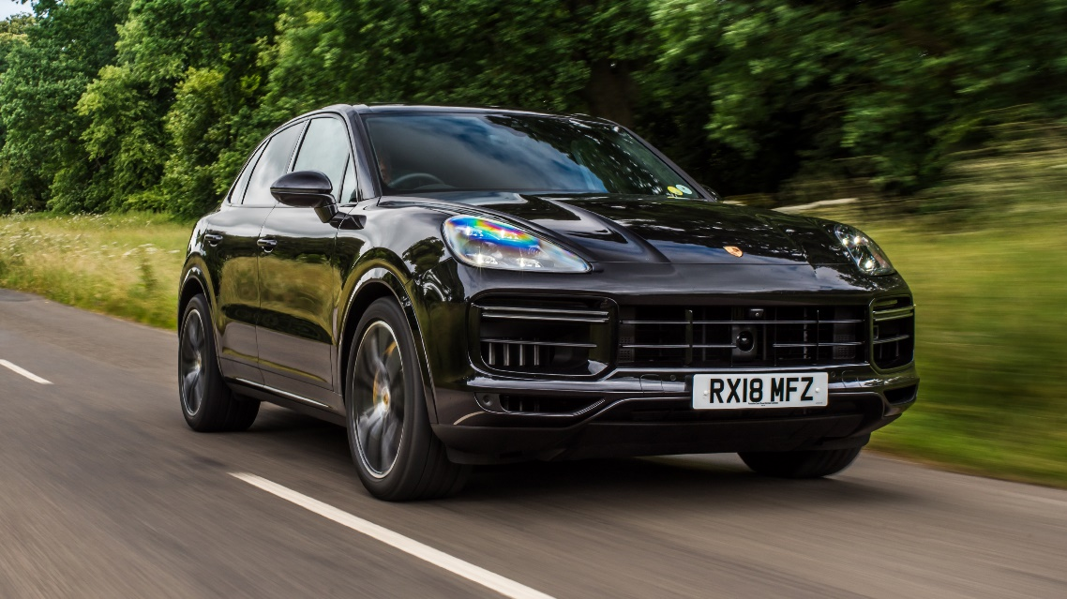

**Features**

|  |  |  |  |  |  |  |  |  |  |
| --- | --- | --- | --- | --- | --- | --- | --- | --- | --- |
| \\ | AC | Child Seat | GPS | Bluetooth | Screen | Parking Sensor | Cup holders | Phone charging | Cruise Control |
| Y/N | **Y** | **Y** | **N** | **N** | **Y** | **Y** | **Y** | **N** | **N** |

__________________________________________________________________

**Luxury**

**Name:** Bentley

**Mileage:**

**Transmission:** Automatic

**Seats:** 5 seats

**Luggage:** 4 bags

**Fuel:** Petrol

**Description:** Bentley Motors Limited is a British manufacturer and marketer of luxury cars and SUVs, and a subsidiary of the Volkswagen Group since 1998. Headquartered in Crewe, England, the company was founded as Bentley Motors Limited by W. O.

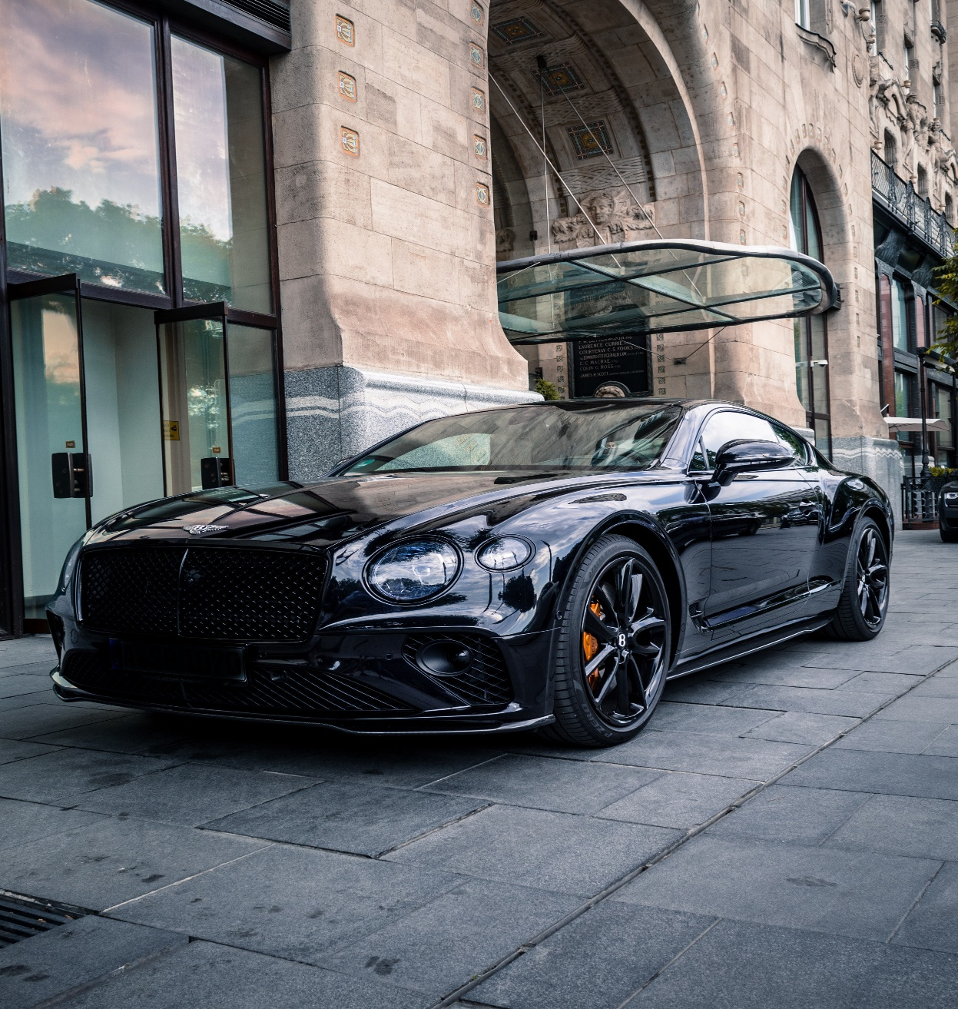

**Features**

|  |  |  |  |  |  |  |  |  |  |
| --- | --- | --- | --- | --- | --- | --- | --- | --- | --- |
| \\ | AC | Child Seat | GPS | Bluetooth | Screen | Parking Sensor | Cup holders | Phone charging | Cruise Control |
| Y/N | **Y** | **N** | **Y** | **Y** | **Y** | **Y** | **Y** | **Y** | **Y** |

__________________________________________________________________

**Name:** Rolls Royce

**Mileage:**

**Transmission:** Automatic

**Seats:** 4 seats

**Luggage:** 2 bags

**Fuel:** Petrol

**Description:** A unique space, defined by unparalleled comfort. The leather in a Rolls-Royce motor car is unlike any other. It is the finest in the world, giving give our craftspeople the most exquisite material to work with.

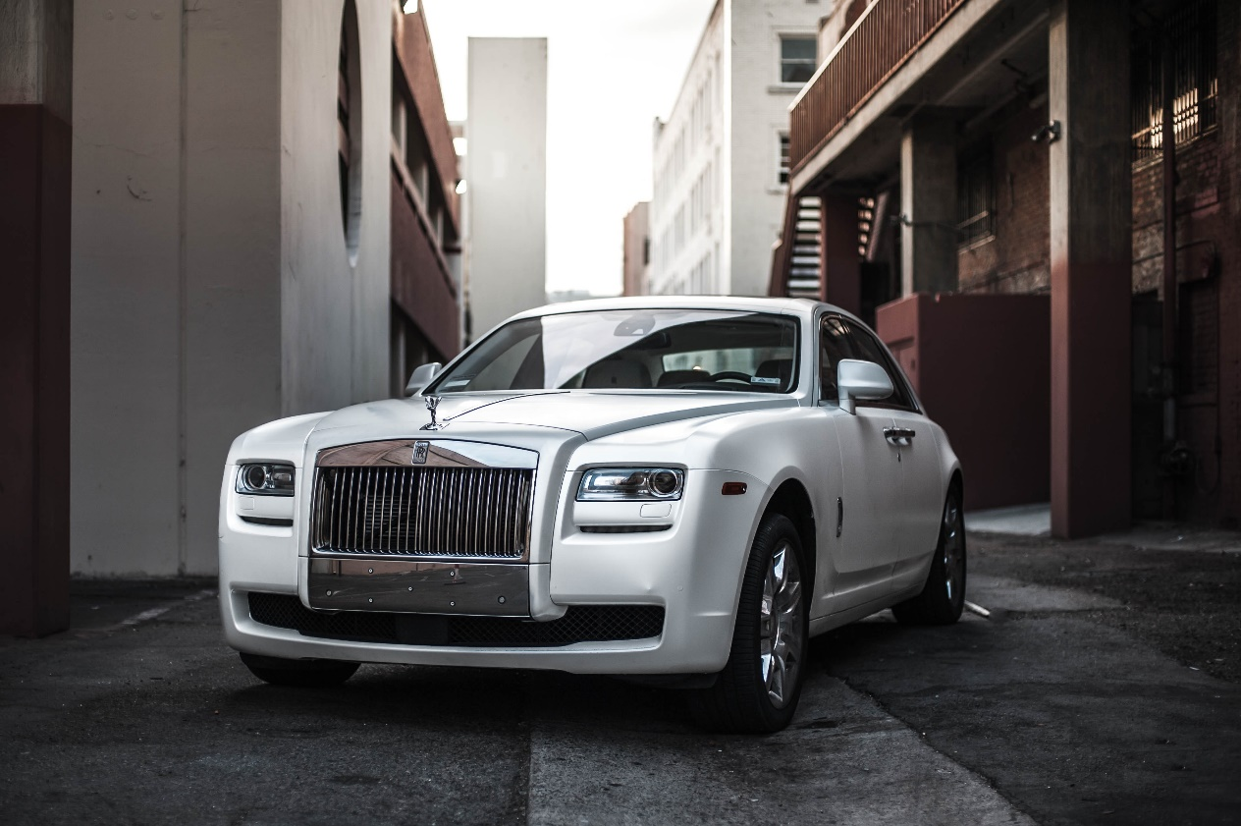

**Features**

|  |  |  |  |  |  |  |  |  |  |
| --- | --- | --- | --- | --- | --- | --- | --- | --- | --- |
| \\ | AC | Child Seat | GPS | Bluetooth | Screen | Parking Sensor | Cup holders | Phone charging | Cruise Control |
| Y/N | **Y** | **N** | **Y** | **Y** | **Y** | **Y** | **Y** | **Y** | **N** |